Problem Set: (Classes, Objects, Constructors and Encapsulation)
1. Create a class named 'Student' with a string variable 'name' and an string variable id_no'. Assign the value of id_no a 'student id' and that of name as "Student name" by creating an object of the class Student.
Program:-
package lab2;
class Student{
String name="student name";
String Id_no="student id";
}
public class class {
public static void main(String[] args) {
Student s=new Student();
}
}
2. Assign and print the roll number, phone number and address of two students having names "Sam" and "John",respectively by creating two objects of the class 'Student'.
Program:
package lab2;

import java.util.*;

class Student1{
int roll_no;
long phone_no;
String address;
String name;
}

public class Objects {

public static void main(String[] args)
{

Scanner sc=new Scanner(System.in);

Student1 sam=new Student1();
Student1 john=new Student1();

System.out.println("Enter SAM's Details:");
sam.name="SAM";
System.out.println("Enter roll number:");
sam.roll_no=sc.nextInt();
System.out.println("Enter phone number:");
sam.phone_no=sc.nextLong();
System.out.println("Enter address:");
sam.address=sc.next();

System.out.println("Enter JOHN's Details:");
john.name="John";
System.out.println("Enter roll number:");
john.roll_no=sc.nextInt();
System.out.println("Enter phone number:");
john.phone_no=sc.nextLong();
System.out.println("Enter address:");
john.address=sc.next();

System.out.println("SAM's Information:");
System.out.println("roll_no:"+sam.roll_no+"\t"+"phone_no:"+sam.phone_no+"\t"+"Address:"+sam.address);

System.out.println("JOHN's Information:");
System.out.println("Name:"+john.name+"\
t"+"roll_no:"+john.roll_no+"\t"+"phone_no:"+john.phone_no+"\t"+"Address:"+john.address);

}

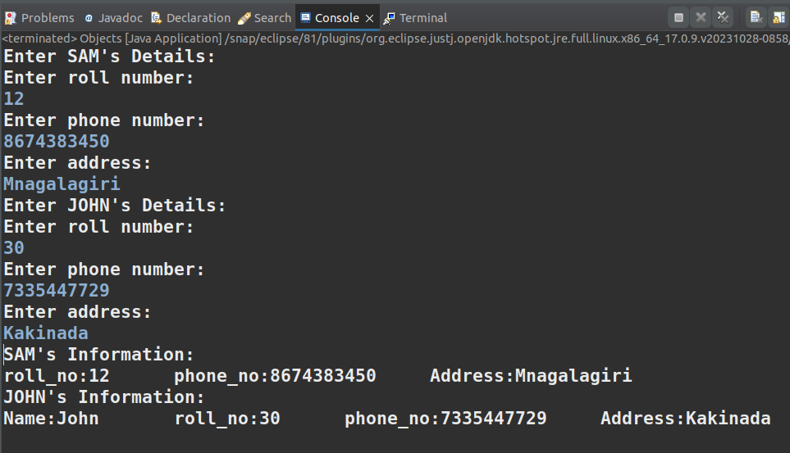
}

}
3. Write a program to print the area and perimeter of a triangle having sides of 3, 4 and 5 units by creating a class named 'Triangle' with a function to printthe area and perimeter.
}package lab2;

class Triangle{
int a=3;
int b=4;
int c=5;
int s=(a+b+c)/2;

void area()
{

System.out.println("Area of a Triangle:");
System.out.println(Math.sqrt((s*(s-a)*(s-b)*(s-c))));
}

void perimeter()
{

System.out.println("Perimeter of a Triangle:");
System.out.println(a+b+c);

}

}

public class Funtion {

public static void main(String[] args)
{

Triangle t=new Triangle();
t.area();
t.perimeter();

}
}
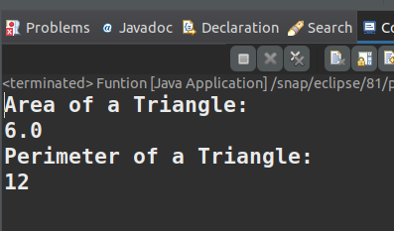

\4. Write a program to print the area and perimeter of a triangle having sides of 3, 4 and 5units by creating a class named 'Triangle' with the constructor having the three sides asits parameters.
Program:-
package lab2;

class Trianglee{

int a,b,c;

Trianglee(int a,int b,int c)
{
this.a=a;
this.b=b;
this.c=c;
}

void show()
{

System.out.println(a+" "+b+" "+c);
}

void area()
{

int s=(a+b+c)/2;
System.out.println("Area of a Triangle:");
System.out.println(Math.sqrt((s*(s-a)*(s-b)*(s-c))));

}

void perimeter()
{

System.out.println("Perimeter of a Triangle:");
System.out.println(a+b+c);
}

}

public class angle {

public static void main(String[] args)
{

Trianglee tt=new Trianglee(3,4,5);
tt.show();
tt.area();
tt.perimeter();}
}

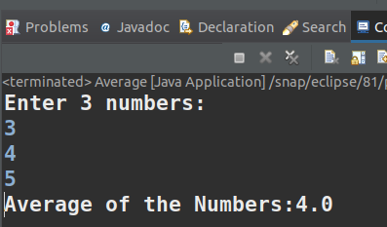

5. Write a program to print the area of two rectangles having sides (4,5) and (5,8)respectively by creating a class named 'Rectangle' with a function named 'Area' whichreturns the area. Length and breadth are passed as parameters to its constructor.
Program:-
package lab2;

class Rectangle
{

int l;
int b;
int c;

Rectangle(int l,int b)
{

this.l=l;
this.b=b;
}

void area()
{

c=l*b;
System.out.println(c);
}

}

public class Rect {

public static void main(String args[])

{

Rectangle r=new Rectangle(4,5);
System.out.println("Area of a Rectangle1:");
r.area();
Rectangle r1=new Rectangle(5,8);
System.out.println("Area of a Rectangle2:");
r1.area();
}
}
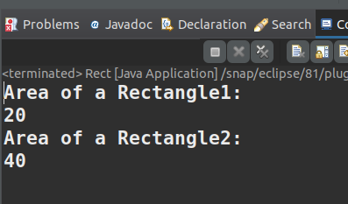

}

}

6. Print the average of three numbers entered by the user by creating a class named 'Average' having a function to calculate and print the average without creating anyobject of the Average class.
Program:-
package lab2;

import java.util.Scanner;

class average{

static void calculate(double n1,double n2,double n3)
{

double num=(n1+n2+n3)/3;
System.out.println("Average of the Numbers:"+num);
}

}

public class Average {

public static void main(String args[]) {
Scanner sc=new Scanner(System.in);
System.out.println("Enter 3 numbers:");
double first=sc.nextDouble();
double second=sc.nextDouble();
double third=sc.nextDouble();
average.calculate(first,second,third);

}

}

7. Write a program that would print the information (name, year of joining, salary,address) of three employees by creating a class named 'Employee'. The output shouldbe as follows: Name Year of joining Address Robert 1994 64C- WallsStreat Sam 200068D- WallsStreat John 1999 26B- WallsStreat
Program:-

package lab2;
import java.util.*;

class Employee{

String Name;
int Year_of_Joining;
String salary;
String address;
int i,n;

public Employee(String Name,int Year_of_Joining,String salary,String address)
{

this.Name=Name;
this.Year_of_Joining=Year_of_Joining;
this.salary=salary;
this.address=address;
}

public void display() {

System.out.println(Name + "\t" + Year_of_Joining + "\t\t" + salary + "\t" +
address);

}
}

public class Emp {

public static void main(String[] args) {

Employee employee1 = new Employee("Robert", 1994,"64C", "-WallsStreat");

Employee employee2 = new Employee("Sam", 2000, "68D", "- WallsStreat");

Employee employee3 = new Employee("John", 1999, "26B", "- WallsStreat");

System.out.println("Name\tYear of Joining\tsalary\tAddress");
employee1.display();
employee2.display();
employee3.display();

}

}
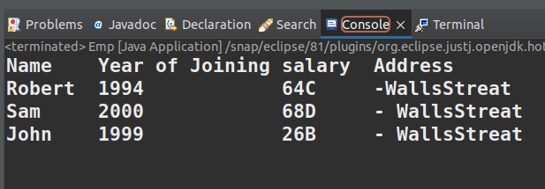

(Object and Classes)

1. Write a program to implement single inheritance with example ( Parent Class- Animal ,Child Class-Dog). [ Variables – 2 Legs, tail, Methods -2 Bark(), Eat()].
Program:-
package lab2;

class animal{

int legs;
int tails;

void bark() {

System.out.println("Dog is barking");
}

void eat()
{
System.out.println("Animal is eating");
}

}

class Dog extends animal{

Dog(int legs,int tails){

System.out.println("No.of legs:"+legs);
System.out.println("No.of Tails:"+tails);
}

void eat()
{
super.eat();
System.out.println("Dog is eating");
}

}

public class class1 {

public static void main(String args[])

{

Dog d=new Dog(2,1);

d.bark();
d.eat();
}

}

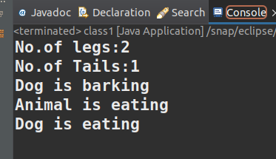

2. Write a program to implement Multiple Inheritance with example( Base Class-1- Subject1(NT), Base Class-2 Subject2(OOPs), Derived Class Student(Name)-1) and Displaythe Subject marks ( MID and END SEM Marks along with student details ;Id,Name,Branch
program:-

3. Write a program to implement Multilevel Inheritance with example( Base class-Animal, Derived Class – Dog , Derived Class- Babydog) and display the details of (Animal,Dog, Babydog).
Program:-
package lab2;

class Animal{

int legs=4;
int tails;

void bark()
{

System.out.println("Animal is barking.");
}

void eat()
{

System.out.println("Animal is eating.");
}

}

class dog extends Animal{

dog(int legs,int tails){

System.out.println("No.of legs for animal:"+super.legs);
System.out.println("No.of legs for dog:"+legs);
System.out.println("No.of Tails for dog:"+tails);
}

void eat()
{

super.eat();
System.out.println("Dog is eating.");
}

}

class BabyDog extends Animal{

BabyDog(int legs,int tails)
{

System.out.println("No.of legs for babydog:"+legs);
System.out.println("No.of tails:"+tails);
}

void bark()
{

System.out.println("BabyDog is slowly barking.");
}

}

public class class3 {

public static void main(String args[])
{

dog d=new dog(4,1);

d.bark();
d.eat();

BabyDog b=new BabyDog(4,1);

b.bark();
b.eat();
}

}

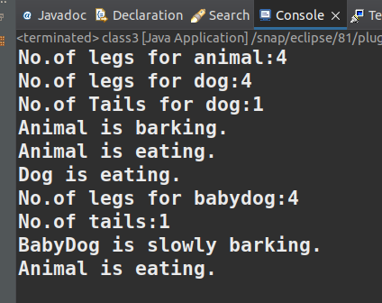

4. Write a program to implement Hierarchical Inheritance withexample( Base Class-Student, Derived Class – student1, Derived Class-Student2) and display the student1,andstudent2 details as id,name,class,branch, college
program:-
package lab2;

class Student{

String ID;
String Name,Class,Branch,College;
}

class student1 extends Student{

student1(String ID,String Name,String Class,String Branch,String
College){

System.out.println("*Student 1 details*");
System.out.println("-----------------");
System.out.println("ID: " + ID);
System.out.println("Name: " + Name);
System.out.println("Class: " + Class);
System.out.println("Branch: " + Branch);
System.out.println("College: " + College);

}

}

class student2 extends Student{

student2(String ID,String Name,String Class,String Branch,String
College){

System.out.println("*Student 2 details*");
System.out.println("-----------------");
System.out.println("ID: " + ID);
System.out.println("Name: " + Name);
System.out.println("Class: " + Class);
System.out.println("Branch: " + Branch);
System.out.println("College: " + College);
}

}

public class class4 {

public static void main(String args[])
{

Student s;

s=new student1("N210764","Varshitha","CSE-04","CSE","RGUKT");
s=new student2("N210701","Sneha","CSE-05","ECE","RGUKT");
}

}

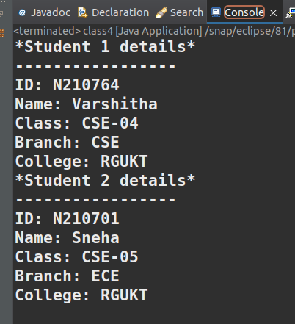

5. Write a program to implement function overloading with change in the number of arguments for display the student details display(Id, Name), display(Id,Name, Branch)
program:-
package lab2;

public class class5
{

public void display(String id, String name)

{

System.out.println("Student ID: " + id);
System.out.println("Student Name: " + name);

}

public void display(String id, String name, String branch)
{

System.out.println("Student ID: " + id);
System.out.println("Student Name: " + name);
System.out.println("Branch: " + branch);

}

public static void main(String[] args)
{

class5 student = new class5();
student.display("N210701", "ketham");
student.display("N210764", "varshi", "CSE");

}

}

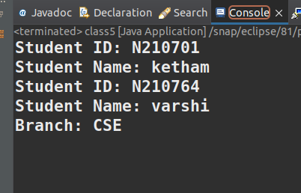

}

6. Write a program to implement function overloading with change in the typde of arguments for display the student details display(Id, Name,Branch,Total Marks), display(Id,Name, Branch,Percentage)
program:-
package lab2;
class Animal{
int legs=2;

void eat() {
System.out.println("Animals are eating");
}

}

class Dog extends Animal{

int legs=4;

void eat()
{

System.out.println("Dogs have "+legs+" legs ");
System.out.println("Dogs are eating");

}

}

public class class6
{
public static void main(String[] args)
{

Ddog a=new Ddog();

a.eat();

}
}

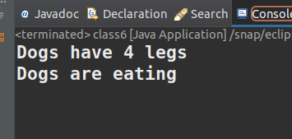

7. Write a program to implement Overriding with example Base Class(Animal) and Derived Class(Dog) variables and methods should be same display the details.
Program:-
package lab2;

class Animal
{

int legs=2;
void eat()
{
System.out.println("Animals are eating.");

}

class dog extends Animal
{
int legs=4;
void eat()
{

System.out.println("No.of legs:"+legs);
System.out.println("Dogs are Eating.");
}

}

public class class7
{
public static void main(String args[])

{

dog d=new dog();
d.eat();

System.out.println(d.legs);

}
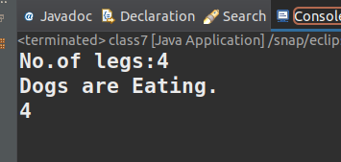
}ts: Object & Class
Concepts: Object & Class
1. Write a proCoConcepts: Object & Class
1. Writ a pConcepts: Object & Class
1. Write a program to create a class for student to get and print details of a
student(idno, name, class, branch).
Program:-rogrC1. Write a program to crConcepts: Object & Class
1. Write a program to create a class for student to get and print details of dno, name, class, branch).
Program:-eaConcepts: ObjteConcepts: Object & Class a class for studenConcepts: Object & Classt toof a
student(idno, name, classavConcepts:Object & Clam to crea
1e a program to create a class for student to get and print details of a
student(idno, name, class, branch).
Program:-
student(idno, name, class, branch).
Program:-create a class for student to get and print details of a
student(idno, ncepts: Object & Class
1. Write a program to create a class for student to get and print details of a
student(idno, name, class, branch).
Program:-gram to create a class for student to get and print details of a
student(idno, name, class, branch).
ProgramConcepts: Object & Class
1. Write a program to create a class for student to :-1. Write a program to create a class 988Concepts: Object & ClassConcept:
1. Write a program to create a class for student to get and print details of a
student(idno, name, class, branch).
Program:-for student to get and print details of a
student(idno,qvConcepts: Object & Class
1. Write a program to create a class for student to get and print details of a
st name, class, branch).
Program:-
Con Concepts: Object & Class
1. Write a program to create a class for student to get and print details of a
student(idno, name, class, branch).
Program:-cepts: Object & Class
1. Write a program to create a class for student to get and print details of a
student(idno, name, class, branch).
Program:-

ncep
Concepts: Object & Class
eCon hgv
v
Program:- a progrConcepts: Object & Class
1. Write a program to create a class for student to get and print details of a
student(idno, name, class, branch).
Program:-am to create a class for student to get and print details of a
student(idno, name, class, branch).
Program:-ncepts: Object & Class
1. Write a program to create a class for student to get and print Concepts: Object & Class
1. Write a program to create a class for student to get and print details of a
student(idno, name, class, branch).
Program:-details of a
student(idno, name, class, branch).
Program:-

Concepts: Object & ClassCc
Object & Cl: Object & Class

